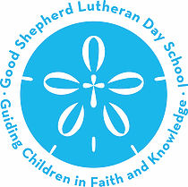
Please Join the FrOGS!!!
Who are the FrOGS???
(Friends of Good Shepherd)
The FrOGS are the Friends of Good Shepherd. Collectively the parents, guardians, relatives and teachers of our children! We accept anyone who wants to help make sure that all the amazing events we have planned throughout the school year go as smoothly as possible. We meet once a month to plan and discuss events, give updates and socialize! It doesn’t matter if you can only make one meeting a year or if you can make all the meetings, please join. We would love to have you! It is also a great way to fulfill your 10 required family volunteer hours for the year.
Here is a list of the FrOGS meetings for the 2018/2019 school year. All meetings are held in Driscoll Hall.
2018-2019 FrOGS Meetings
August 14th – 8:00am
September 11th – 8:30am
October 9th – 8:30am
November 13th – 8:30am
December 11th – 8:30am
January 15th – 8:30am
February 12th – 8:30am
March 12th – 8:30am
April 9th – 8:30am
May 21st – 8:30am

THANK YOU AND WE LOOK FORWARD TO SEEING YOU AT OUR FIRST MEETING!

